Clerks Report
- Play Park Replacement Parts (Swing)
Contractor 1

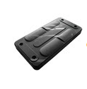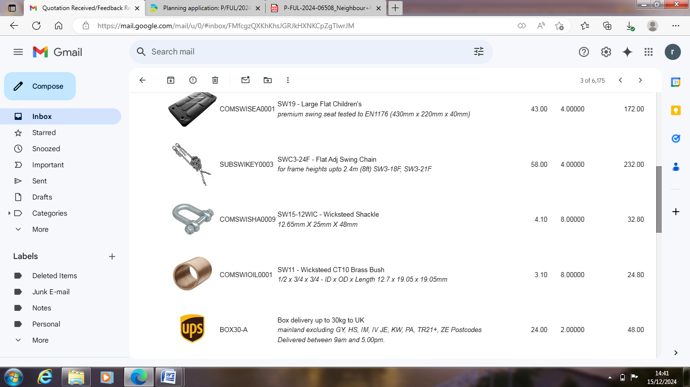

Large Flat Children's - Premium swing seat tested to EN1176 (430mm x 220mm x 40mm) Qty 4 £172.00
Flat Adj Swing Chain - For frame heights upto 2.4m (8ft) Qty 4 (Sets) £232.00
Wicksteed Shackle - 12.65mm X 25mm X 48mm Qty 8 £32.80
Wicksteed CT10 Brass Bush - 1/2 x 3/4 x 3/4 - ID x OD x Length 12.7 x 19.05 x 19.05mm Qty 8 £24.80
Delivery £48.00
Net Total: £509.60
VAT: £101.92
Total: £611.52

- Clerk to prepare an advert, job description and job specification for the permanent Clerks role. – ANNEX
To discuss and agree a way forward with the draft advert, job description and specification.

- Action Log
To discuss / note updates on actions taken since the last meeting.
Action Number (Month year - Agenda number) | When Initiated | Who to Action | Title | Details | Status
1224-4 | 03/12/2024 | Cllr Bugler | Passing point signage | 03-12-24 Cllr Bugler to respond to Dorset Council to amend the signage to no parking any time of day as this is a passing place lay-by not a parking lay-by. Once artwork amended to place the order.
1224-4 | 03/12/2024 | Cllr Burden | Defibrillator St Aldhelms. | 03-12-24 To cover the cost of a new cabinet up to the value of £629. Cllr Burden to advice representative accordingly.
1224-4 | 03/12/2024 | Clerk | Alzheimer’s Society Trek Fundraiser June 2025 | 03-12-24 Clerk to respond to the Alzheimer’s Society representative to confirm Worth Matravers Parish Council is happy to support their event by allowing use of the overflow area car park between Friday 16th June and Sunday 18th June 2025 at no cost. 04-12-24 Email sent | Complete
1224-4 | 03/12/2024 | Cllr Bugler | Digital Parking Charges | 03-12-24 Cllr Bugler to contact Just park to approve they install a digital payment method within the Worth Matravers Village main car park. Cost to be £3 up to mid night each day. 11-12-24 Email sent | Complete
1224-4 | 03/12/2024 | Clerk | Councillor resignation | 03-12-24 Clerk to inform Dorset Council to start the public notification period. Plus to create a poster advertising the post availability 05-12-24 DC Elections notified | On Going
1224-6 | 03/12/2024 | Clerk | Planning - P/HOU/2024/06619 | 03-12-24 Clerk to circulate a proposed response to Councillor, before submitting to Dorset Council 10-12-24 response submitted to DC after consultation with Cllr's | Complete
1224-8 | 03/12/2024 | Cllr Bugler | Jan Agenda | 03-12-24 Cllr Bugler offered to place the January agenda due to Christmas Holidays

